**Project Title: GradTrak**

CMPS 4910-03: Senior Project 1

End-of-Term Progress Report: Justin Ulloa, Tristan Bock, Shadi Razzak, Haylee Allen

Date: December 9, 2022

Table of Contents

**1** **OVERVIEW** 3

1.1 **Changes to Project** 3

**2** **Updated Project Plan** 3

**3** **Updated Timeline** 3

3.1 **Table 1. Timeline** 3

1. **OVERVIEW**

In the oncoming sections we will be providing a detailed summary of any changes that will or will not be made to our project, an updated project plan, and an updated timeline.

* 1. **Changes to Project**

1. **Updated Project Plan**

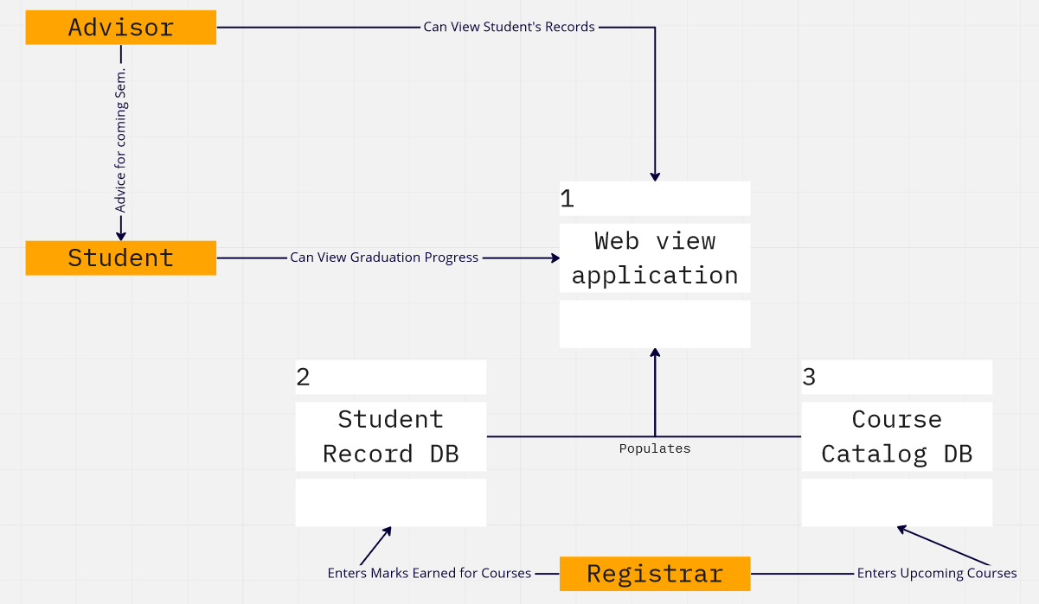 Since the initial proposal we’ve discussed a little and all gotten on the same page how the project should eventually work – being as close to DegreeWorks and equivalent as possible for being a student assignment. It needs to be a tool as much for advisors and the Registrar as it is for students, to make sure that grade viewing and entry is the least stressful thing about university. Sufficient and necessary courses should show up for each graduation requirement, advisors need to be able to see student records to suggest courses and long term plans, and the registrar needs to easily be able to edit the catalog and student records and have it properly show up in the database.

1. **Updated Timeline**

Updated project timeline that displays our projects goals, estimated due dates, and descriptions of what exactly we aim to achieve.

* 1. **Table 1. Timeline**

|  |  |  |
| --- | --- | --- |
| **Goal** | **Date** | **Description** |
| 1.**Database Setup** | **Jan. 30th – Feb. 15th** | **Work on establishing a basic foundation of query inputs to build off from** |
| **2. UI Rough Setup** | **Feb 16th – Feb. 27th** | **Begin building a rough setup of the UI to get a better idea as to what expect our application to look like** |
| **3. Connecting UI & Database** | **March 1st – March 20th** | **Connect the database to the application and assure that everything being inputted is functioning correctly** |
| **4. Testing** | **March 21st – April 14th** | **Debugging phase where will test features that were implemented into the application and correct any errors** |
| **5. Clean up & Final Touches** | **March 21st – April 14th** | **Polish the UI from its initial setup and make it more user friendly. Reflect on our initial goals and confirm that they have all been met, as well as adding additional features if possible** |